I created the front panel graphics using Inkscape v1.2

I created two layers – the main layer (Layer 1) has all of the graphics and images on it, and I created a second layer (Knob outlines) that I used as a guide to offset the text and graphics from the knobs themselves.

Creating the switch scale

- I cloned the following repository: https://github.com/brathering82/inkscape.git into F:\Dev\inkscape
- Opened the latest release directory (v0.91) and copied render_scale.inx and render_scale.py to: c:\program files\inkscape\share\inkscape\extensions
- Restarted inkscape
- Scale generator appears under Extensions > Render

However everything I did generated an error – long python exception.

I tried again, by downloading and installing Synth Panel Designer from here:

https://gitlab.com/Faselunare/synth-panels-designer

In Inkscape go to Edit > Preferences > System and open the User Extensions folder

Create a directory in there called SynthPanelsDesigner & copy everything from the cloned directory into there.

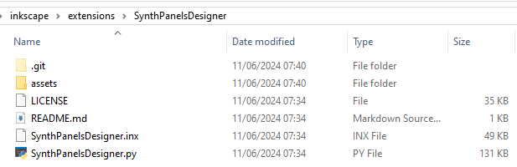

Restart inkscape

Synth Panels Designer is available under Extensions > Render

To draw a scale, you have to draw a knob first, then select the knob before drawing the scale.

